Trace Tables - Student booklet
Y10 - Cambridge IGCSE Computer Science 0478 | Algorithm design and problem-solving
Name: _______________________________ | Date: _____________

- Learn sections show the key slides from the lesson. Read them, then do the task straight after.
- Cross off each input value as you use it, and only write a value in a trace table when it changes.
- Tasks 2-5 are real Cambridge 0478 Paper 2 questions. Your teacher will share the answers.
Task 1 Starter: true or false? [5 marks]
Write T (true) or F (false) for each statement. If it is false, correct it.
# | Statement | T / F | Correction if false
1 | A trace table has one column for each variable and one column for OUTPUT.
2 | A dry run means running the program on a computer to see what it does.
3 | You must write the value of every variable in every row of a trace table.
4 | Totalling uses a statement like Total ← Total + Value inside a loop.
5 | To find the largest value, the variable that stores it should start as a very large number.
Learn What a trace table is
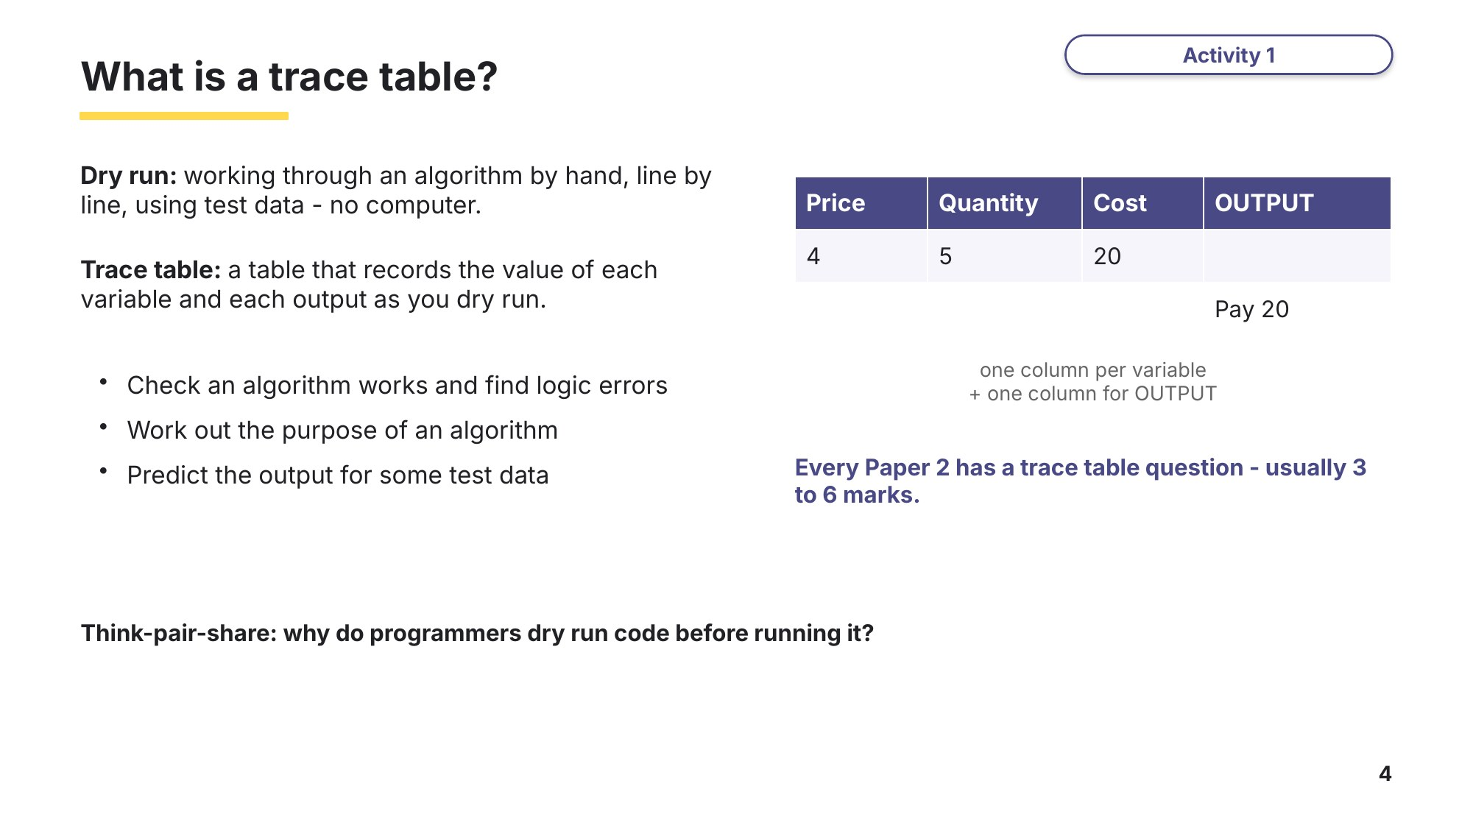
Slide 4 - What is a trace table?
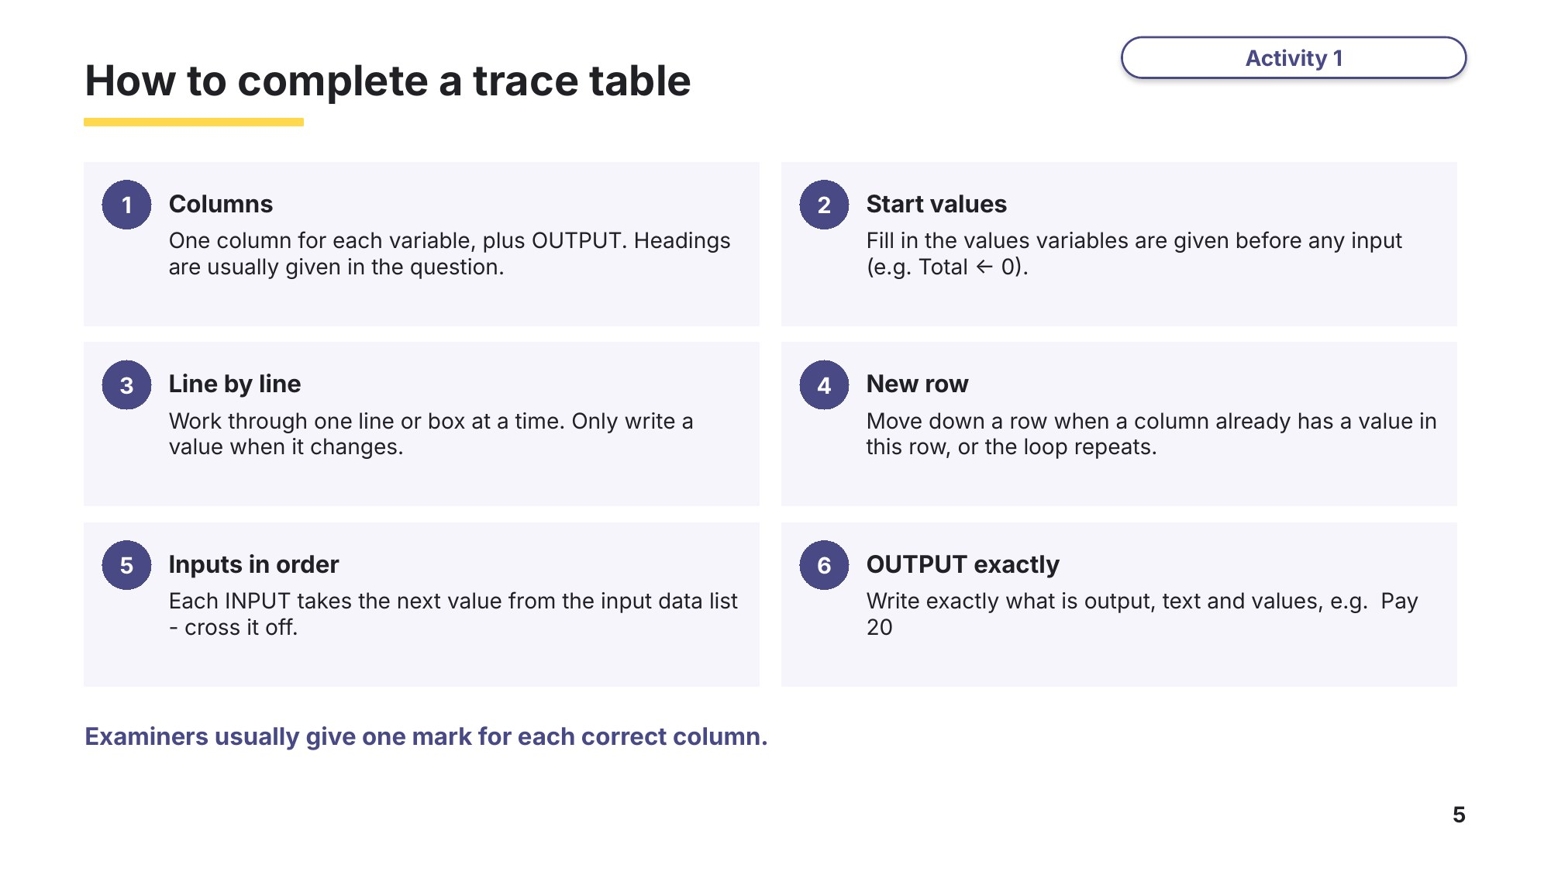
Slide 5 - How to complete a trace table
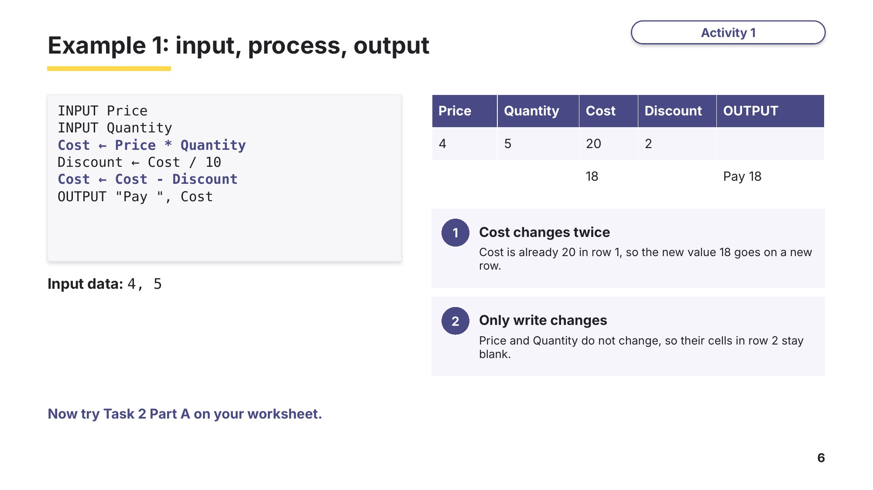
Slide 6 - Example 1: input, process, output
Task 2 Tracing the basics [16 marks]
Part A Input, process and output (no input data)
This pseudocode uses two variables, A and B.
A ← 3
B ← 8
A ← A + B
B ← A - B
A ← A - B
OUTPUT A, " ", B
(a) Complete the trace table for the algorithm. [2]
A | B | OUTPUT

(b) State what the algorithm does to the values stored in A and B. [1]

Learn Tracing a flowchart
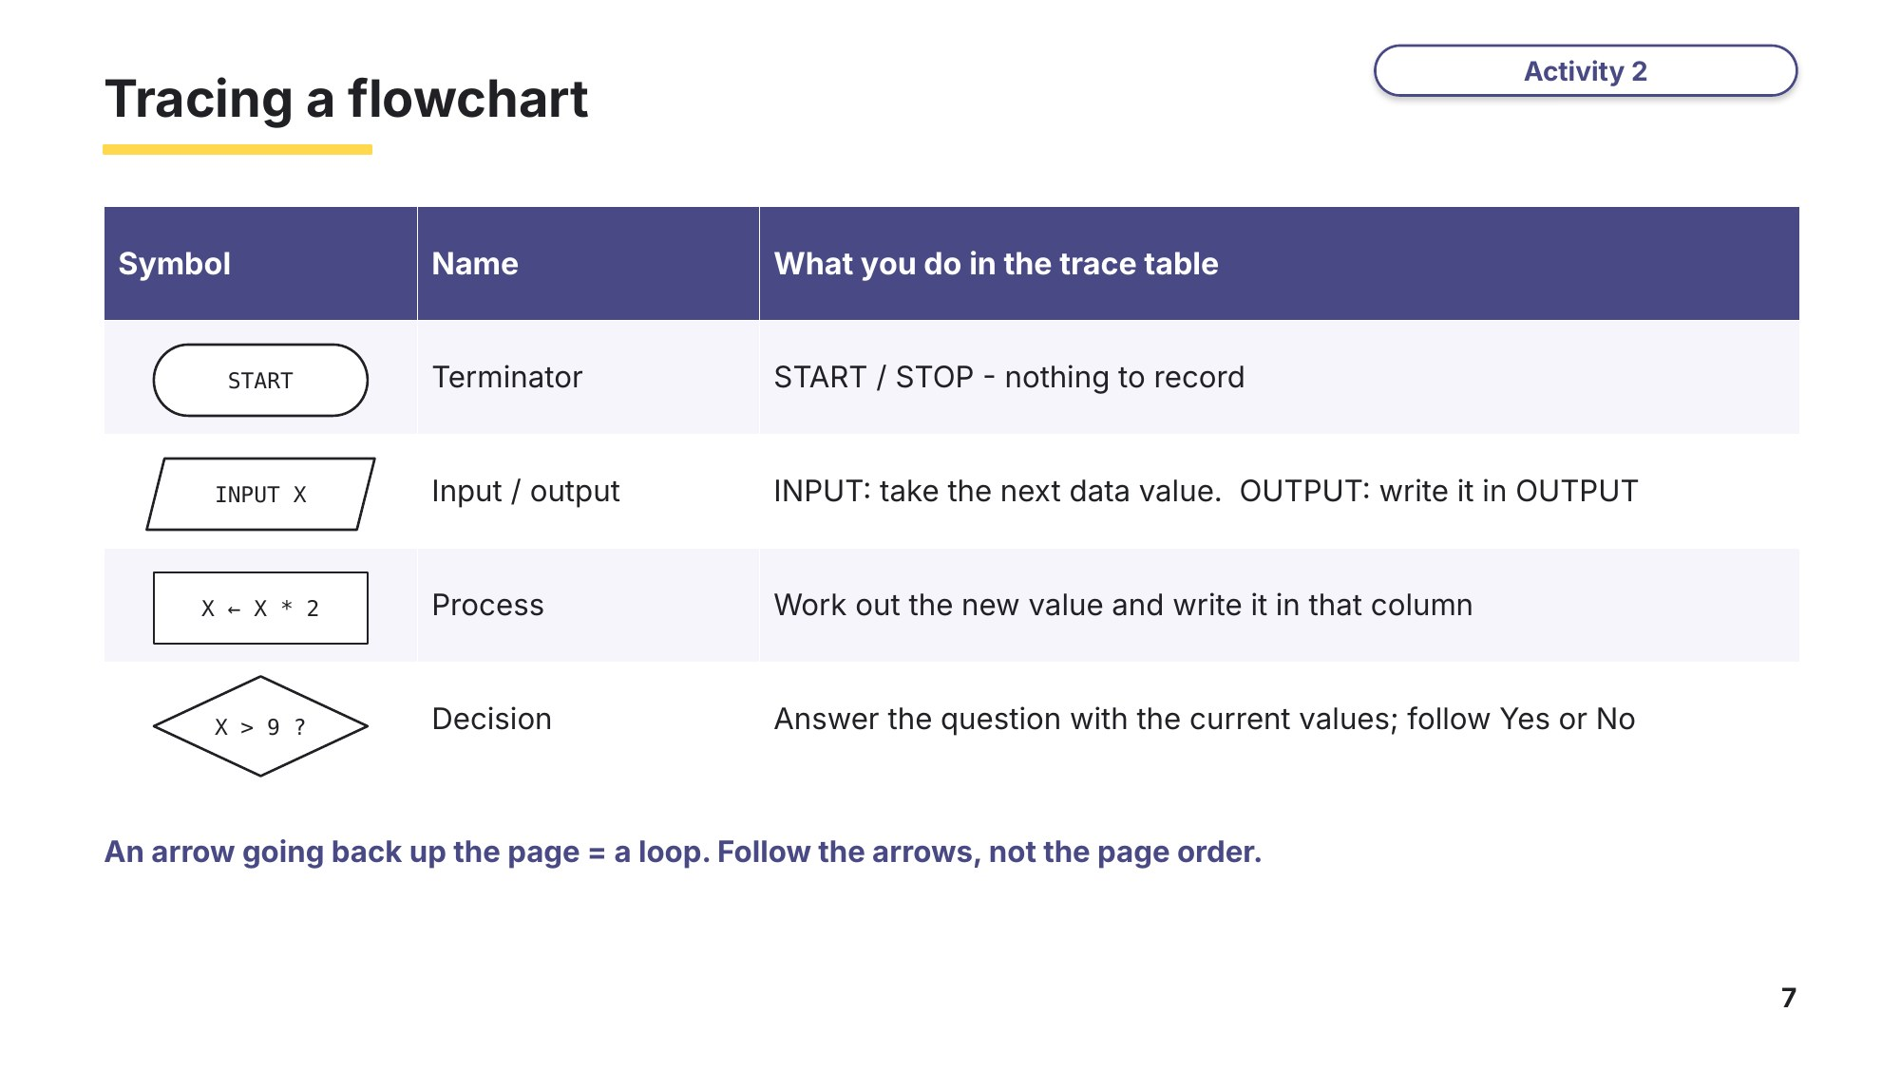
Slide 7 - Tracing a flowchart
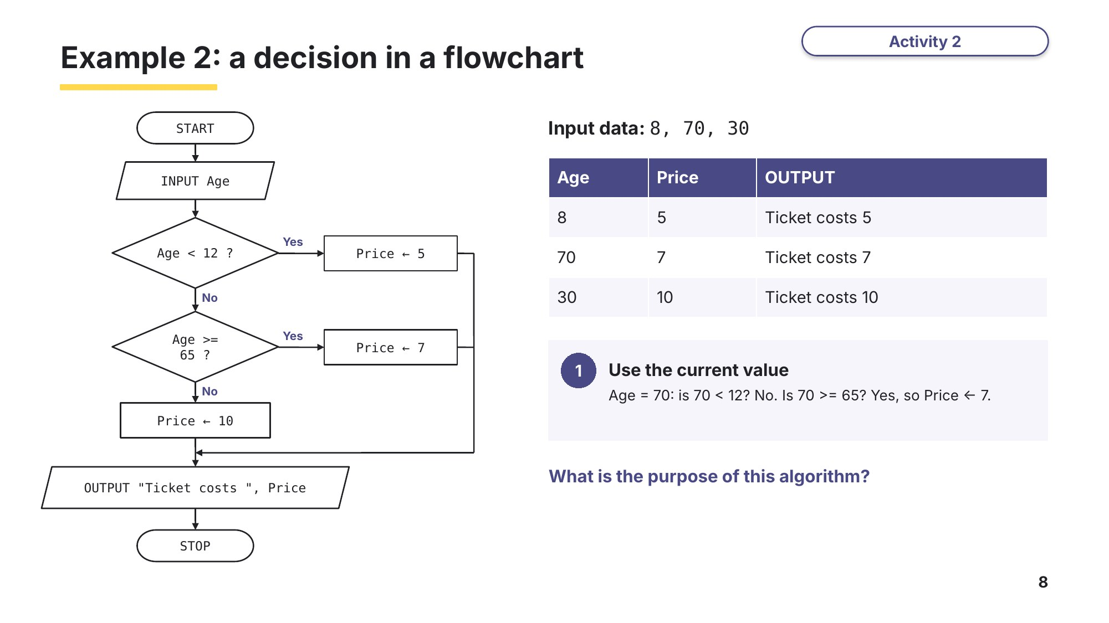
Slide 8 - Example 2: a decision in a flowchart
Part B Selection in a flowchart
The flowchart represents an algorithm to calculate grades.
0478/21 May/June 2025 Q10
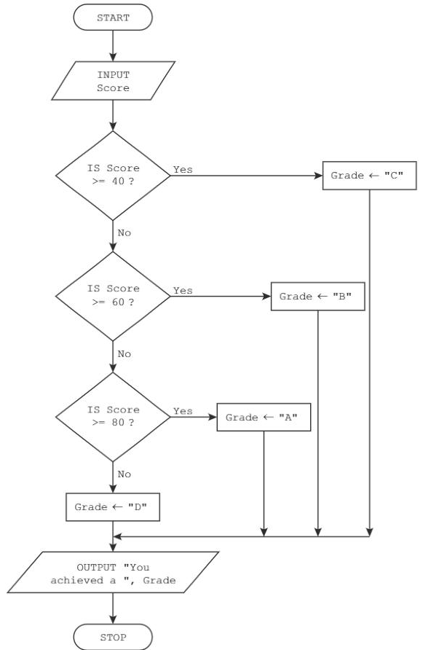
(a) Complete the trace table for the algorithm, using the input data: 21, 46, 63, 91, 12 [3]
Hint: the flowchart has no loop, so trace it once for each input value, one row per value.
Score | Grade | OUTPUT

(b) Explain how the flowchart can be changed to produce the correct output. [4]

Part C Input, selection and a loop
This flowchart represents an algorithm.
0478/22 February/March 2025 Q7(a) and (b)
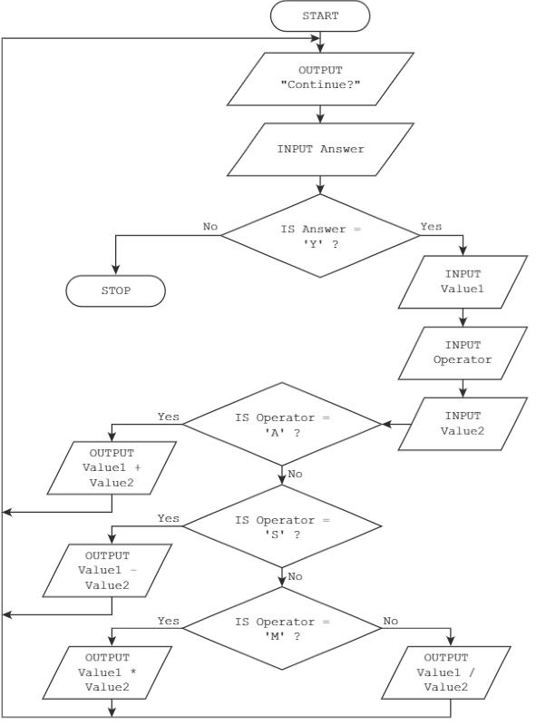
(a) Complete the trace table for the input data: Y, 7, S, 9, Y, 5, M, 12, Y, 25, D, 5, N, 10, A, 6 [5]
Answer | Value1 | Operator | Value2 | OUTPUT

(b) State the purpose of the algorithm. [1]

Learn Loops, totalling and counting
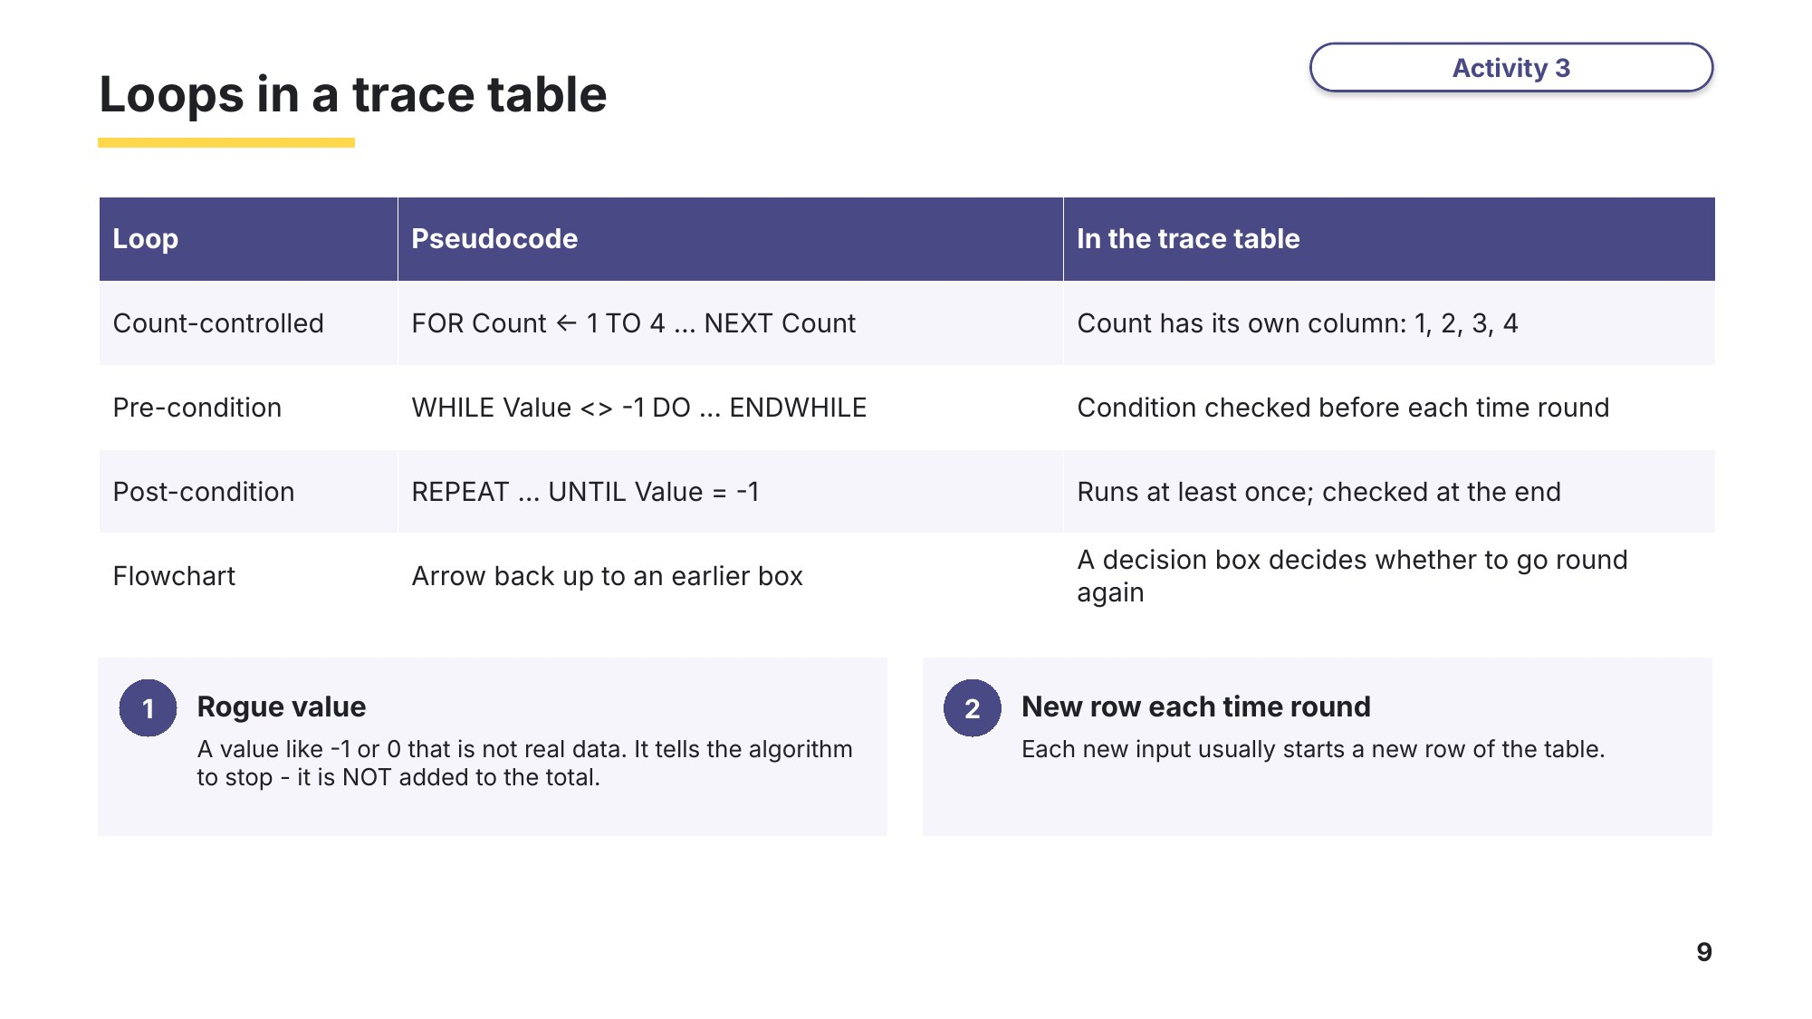
Slide 9 - Loops in a trace table
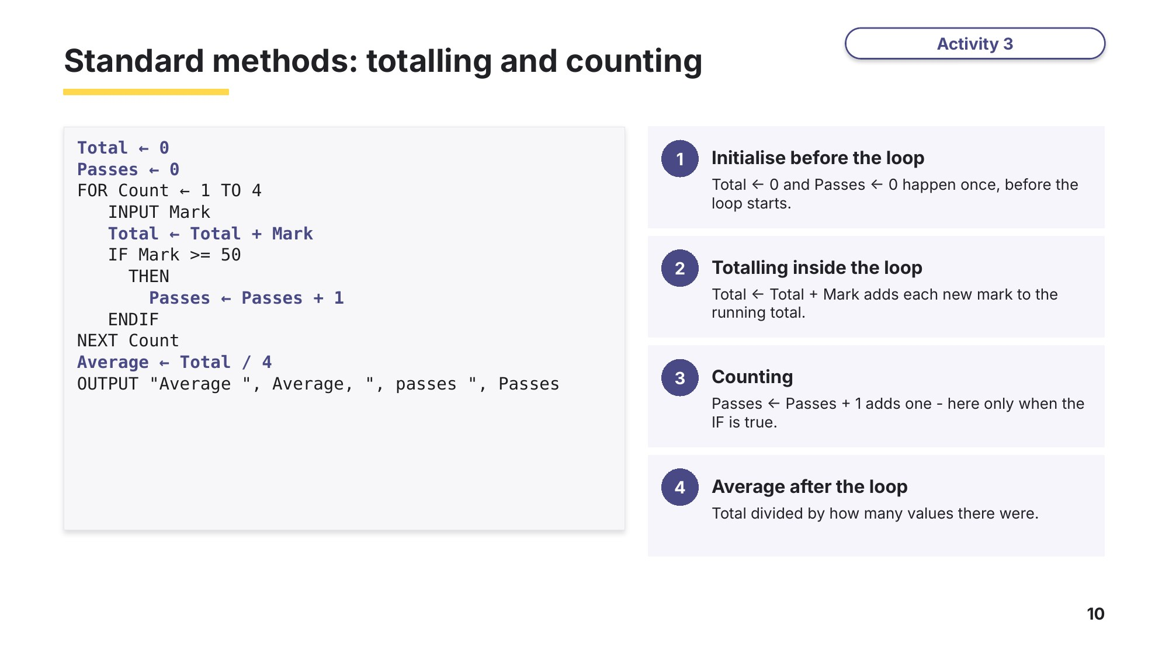
Slide 10 - Totalling and counting
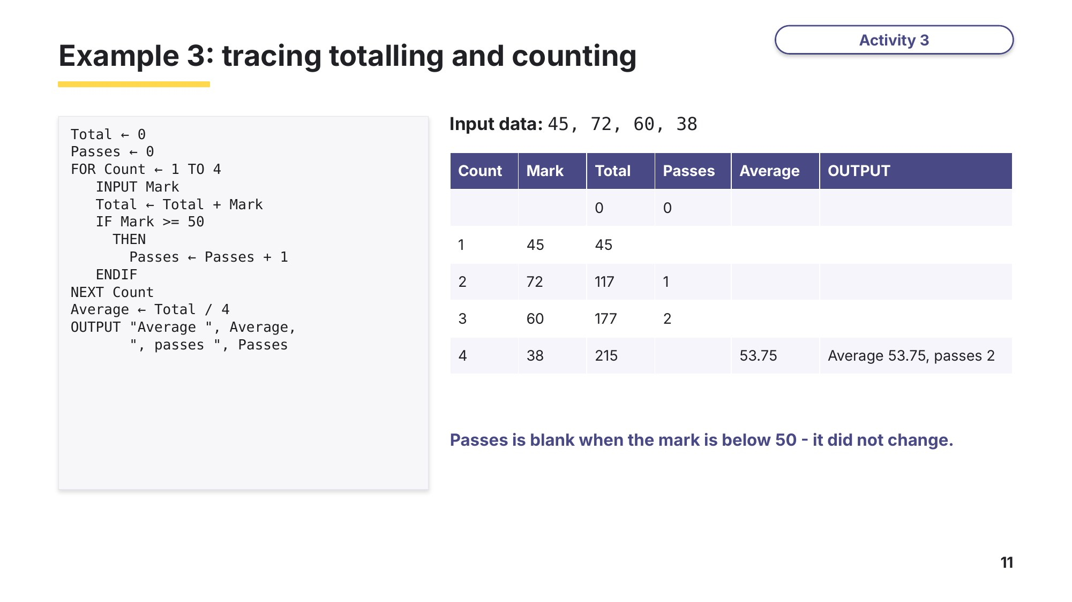
Slide 11 - Example 3
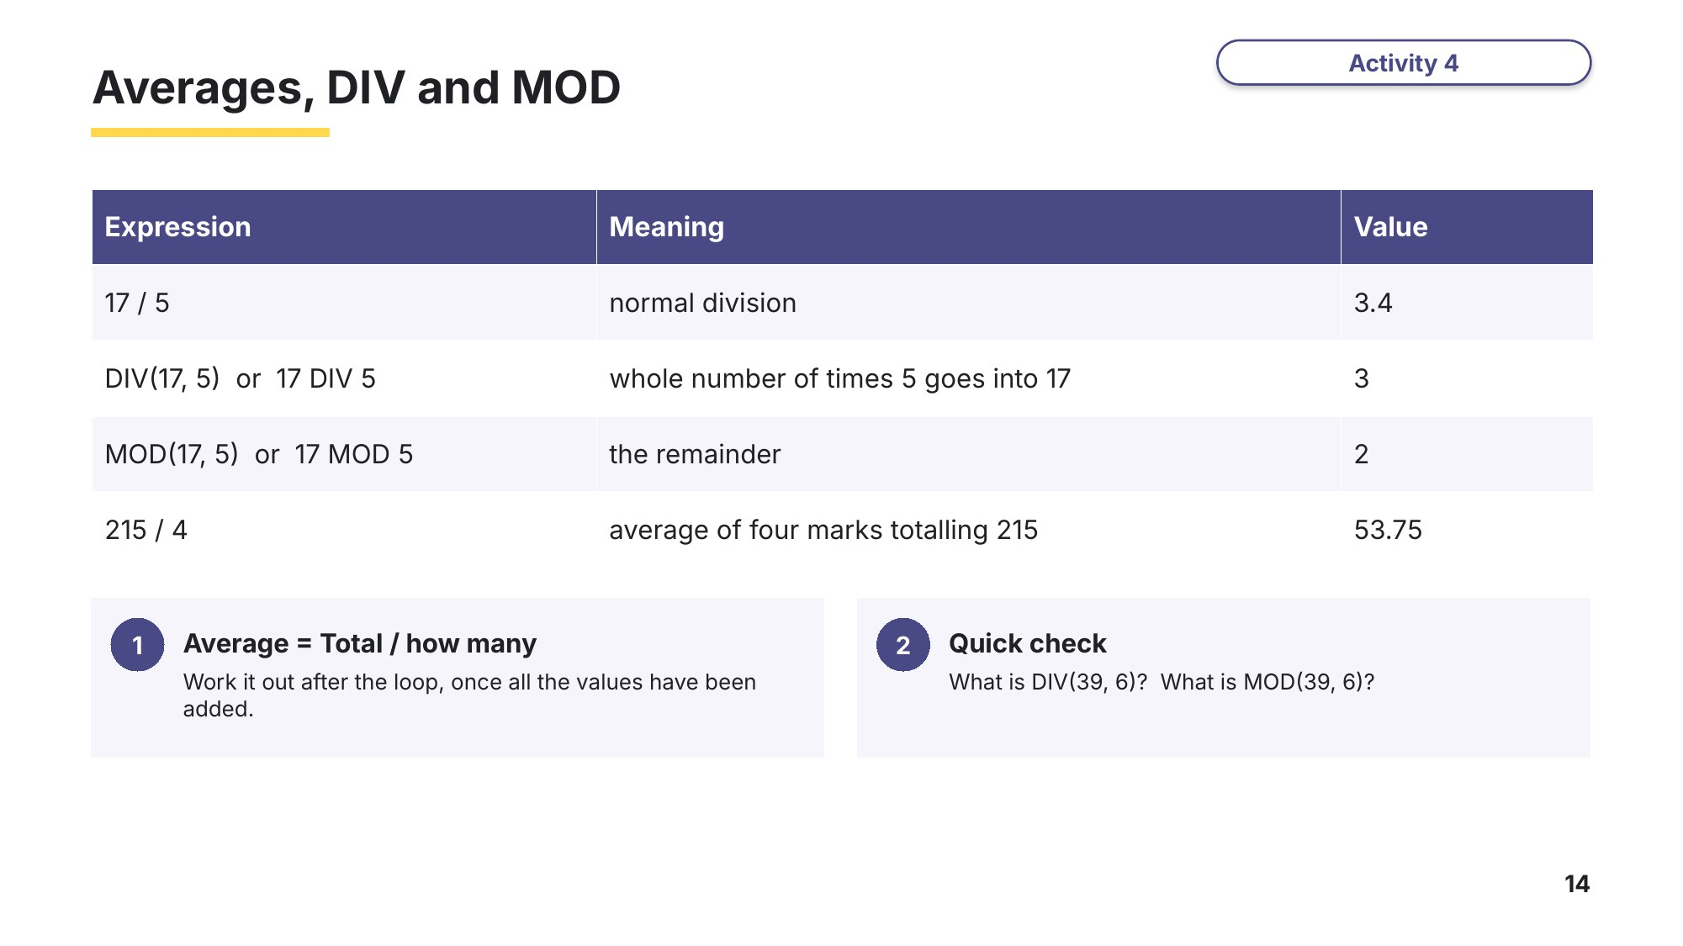
Slide 14 - Averages, DIV and MOD
Task 3 Totalling and counting [11 marks]
Part A Average group size
This flowchart represents an algorithm to find the average size of groups of visitors to an attraction.
0478/22 February/March 2024 Q8
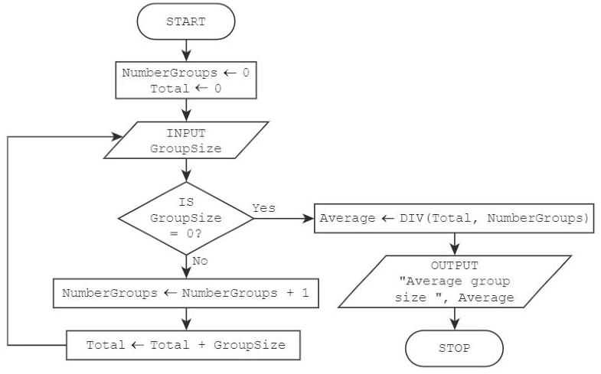
DIV(Total, NumberGroups) divides Total by NumberGroups and gives the whole-number part only, e.g. DIV(17, 5) = 3.
Complete the trace table using this data: 7, 10, 2, 8, 3, 9, 0, 6 [4]
NumberGroups | Total | GroupSize | Average | OUTPUT

Part B Totals and averages for groups of values
The flowchart represents an algorithm that performs a process on groups of values that are input. The algorithm will fail if the first value of any group is 0. An input of –1 will terminate the algorithm.
0478/22 October/November 2023 Q6(a) and (b)
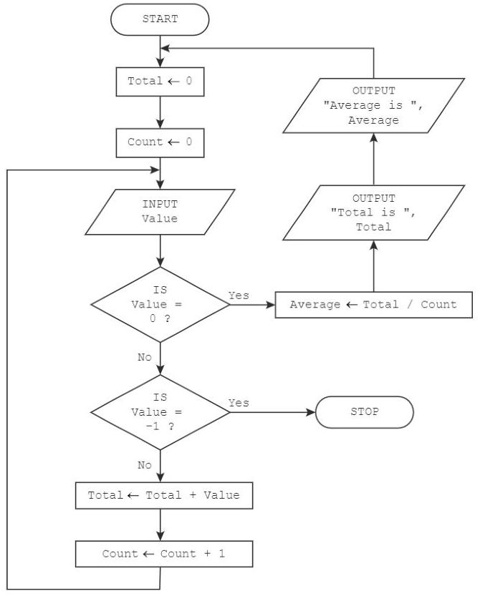
(a) Complete the trace table for the input data: 25, 35, 3, 0, 57, 20, 25, 18, 0, –1, 307, 40, 0 [5]
Value | Average | Total | Count | OUTPUT

(b) Describe the purpose of the algorithm. [2]

Learn Maximum and minimum
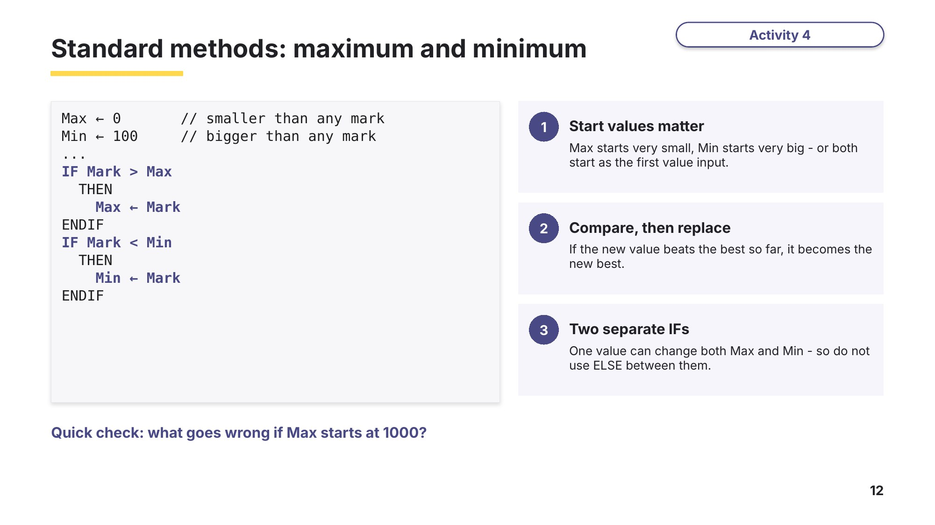
Slide 12 - Maximum and minimum
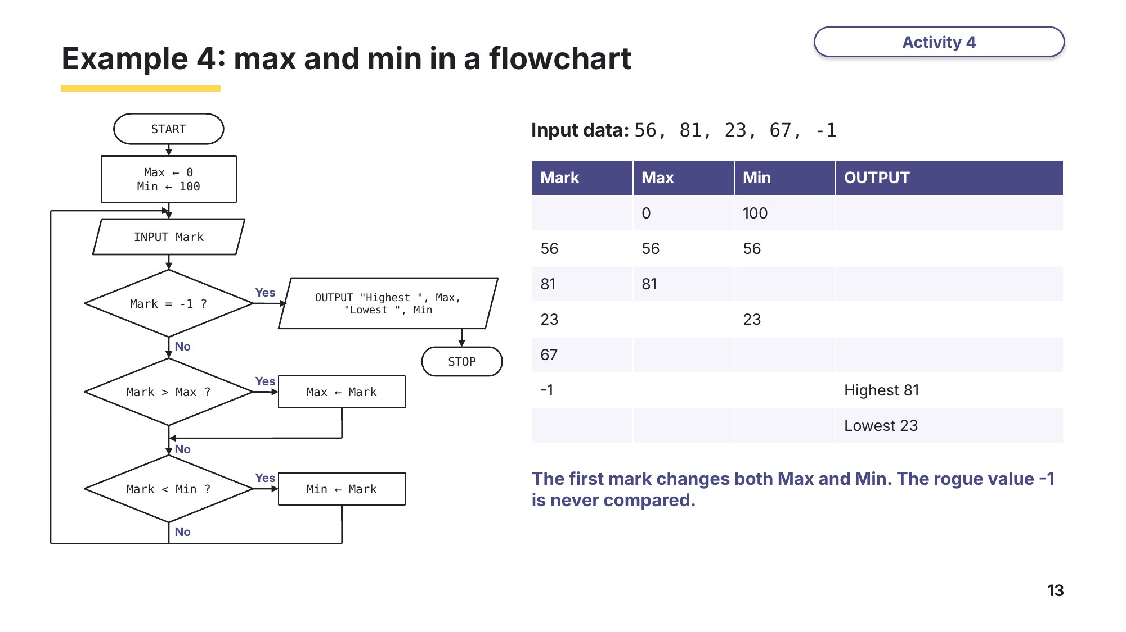
Slide 13 - Example 4: max and min in a flowchart
Task 4 Maximum and minimum [14 marks]
Part A Highest and lowest in pseudocode
A program has been written in pseudocode to input five numbers between 1 and 900 inclusive and store the highest number and the lowest number entered.
0478/23 October/November 2025 Q5
01 Lowest ← 900
02 Highest ← 1
03 FOR Count ← 1 TO 5
04 INPUT Number
05 IF Number < Lowest
06 THEN
07 Lowest ← Number
08 ELSE
09 IF Number > Highest
10 THEN
11 Highest ← Number
12 ENDIF
13 ENDIF
14 NEXT Count
(a) Complete the trace table for the algorithm using the following numbers: 563, 21, 376, 99, 400 [4]
Count | Number | Lowest | Highest

(b) The algorithm does not work correctly. State the reason why the algorithm does not work as expected and explain how the algorithm could be corrected. Any code used must be fully explained. [2]
Reason

Correction

Part B Largest, smallest, total and average in a flowchart
The flowchart represents an algorithm.
0478/23 May/June 2024 Q5(a) and (b)
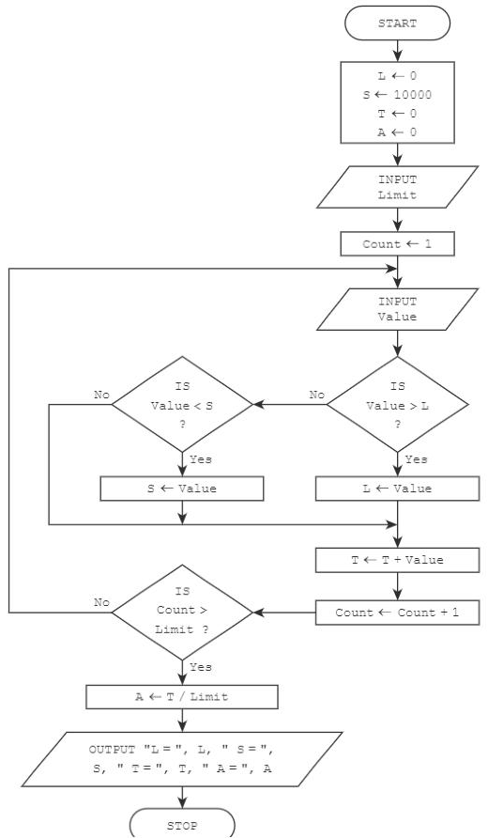
(a) Complete the trace table for the input data: 10, 30, 18, 8, 25, 12, 17, 2, 50, 15, 5 [6]
L | S | T | A | Limit | Count | Value | OUTPUT

(b) Outline the purpose of the algorithm. [2]

Learn How examiners mark trace tables
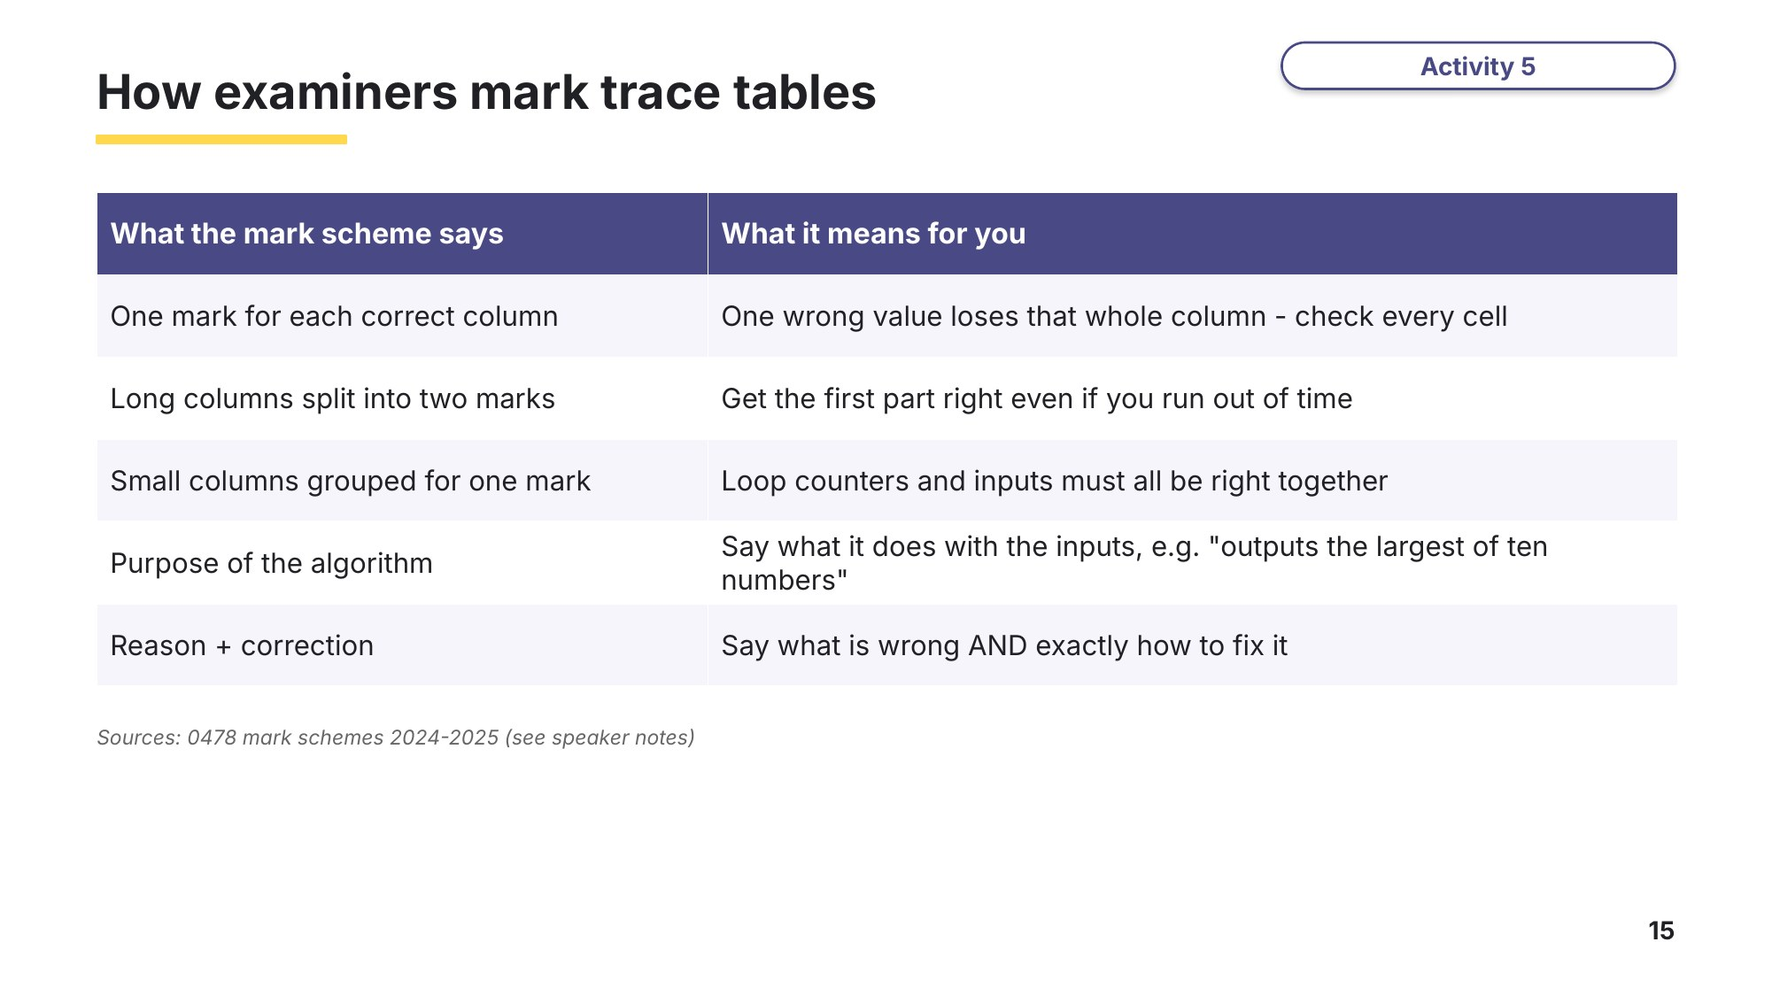
Slide 15 - How examiners mark trace tables
Use this as a checklist when you mark your own answers to Tasks 2-4.
Task 5 Extension: a loop inside a loop [11 marks]
Part A
This pseudocode represents an algorithm. An input of –1 will terminate the algorithm.
0478/22 October/November 2024 Q7
DECLARE Count : INTEGER
DECLARE Answer : INTEGER
DECLARE Value : INTEGER
REPEAT
INPUT Value
IF Value <> -1
THEN
Answer ← Value
FOR Count ← Value - 1 TO 1 STEP -1
Answer ← Answer * Count
NEXT Count
OUTPUT Answer
ENDIF
UNTIL Value = -1
STEP -1 makes the FOR loop count down: Value - 1, then one less each time, down to 1.
(a) Complete the trace table for the input data: 5, 6, –1, 20, 9, 4 [5]
Value | Count | Answer | OUTPUT

(b) State the purpose of this algorithm. [1]

(c) Describe the problem that would be caused in this algorithm if a Value of 1, 0 or less than –1 was input. [2]

Part B Stretch: back to the calculator
0478/22 February/March 2025 Q7(c)(i)
Look again at the calculator flowchart in Task 2 Part C. There are problems with the given algorithm. If the lower-case letter ‘y’ is entered for Answer, the algorithm stops and if a lower-case letter is entered for Operator, the algorithm gives an incorrect output.
Explain how you would change the algorithm to prevent the problems described. [3]

Task 6 At the computer: predict, then run
This VB.NET program uses totalling, counting and a maximum. For Day = 1 To 5 ... Next is VB.NET for FOR Day ← 1 TO 5 ... NEXT Day.
Module Module1
Sub Main()
Dim Day, Temp, Total, Highest, HotDays As Integer
Total = 0
Highest = -100
HotDays = 0
For Day = 1 To 5
Console.Write("Temperature for day " & Day & ": ")
Temp = CInt(Console.ReadLine())
Total = Total + Temp
If Temp > Highest Then
Highest = Temp
End If
If Temp >= 30 Then
HotDays = HotDays + 1
End If
Next
Console.WriteLine("Total: " & Total)
Console.WriteLine("Highest: " & Highest)
Console.WriteLine("Hot days: " & HotDays)
Console.WriteLine("Average: " & Total / 5)
Console.ReadKey()
End Sub
End Module
(a) Predict first. Complete the trace table for the input data 28, 31, 26, 33, 30. Ignore the "Temperature for day" prompts in the OUTPUT column.
Day | Temp | Total | Highest | HotDays | OUTPUT

(b) Make a new Console App (Visual Basic) called Temperatures, type in the program and run it with the same data. Did your trace table predict the output correctly? If not, find the row where you went wrong.

(c) Why does Highest start at -100? Change it to 0, then find five temperatures that make the program output the wrong highest value.

(d) Stretch: add a variable Lowest that finds the coldest day. Choose its start value carefully, then trace and run your new program.

Learn Review
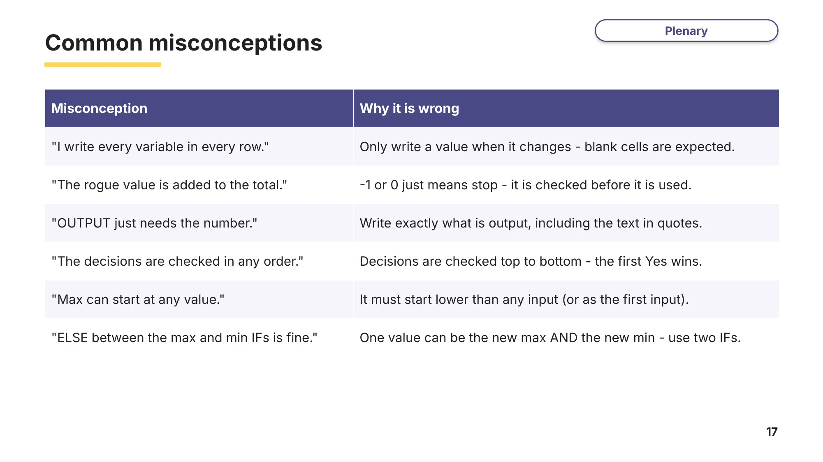
Slide 17 - Common misconceptions
Look back at your Task 1 answers. Change any that you now think are wrong.
Exit question
Count ← 0
INPUT Num
WHILE Num <> 0 DO
IF Num > 10
THEN
Count ← Count + 1
ENDIF
INPUT Num
ENDWHILE
OUTPUT Count
Complete the trace table for the input data 14, 3, 22, 0, then state the purpose of the algorithm.
Num | Count | OUTPUT
Purpose

